**FOR DEMONSTRATION YOU CAN VISIT OUR SITE AT-----**

[**www.codechefcgc.team**](http://www.codechefcgc.team)

**WEBSITE HOME PAGE------------------------------------------------------**

**DISPLAYING THE WINNERS OF LATEST CONTEST ORGANISED**

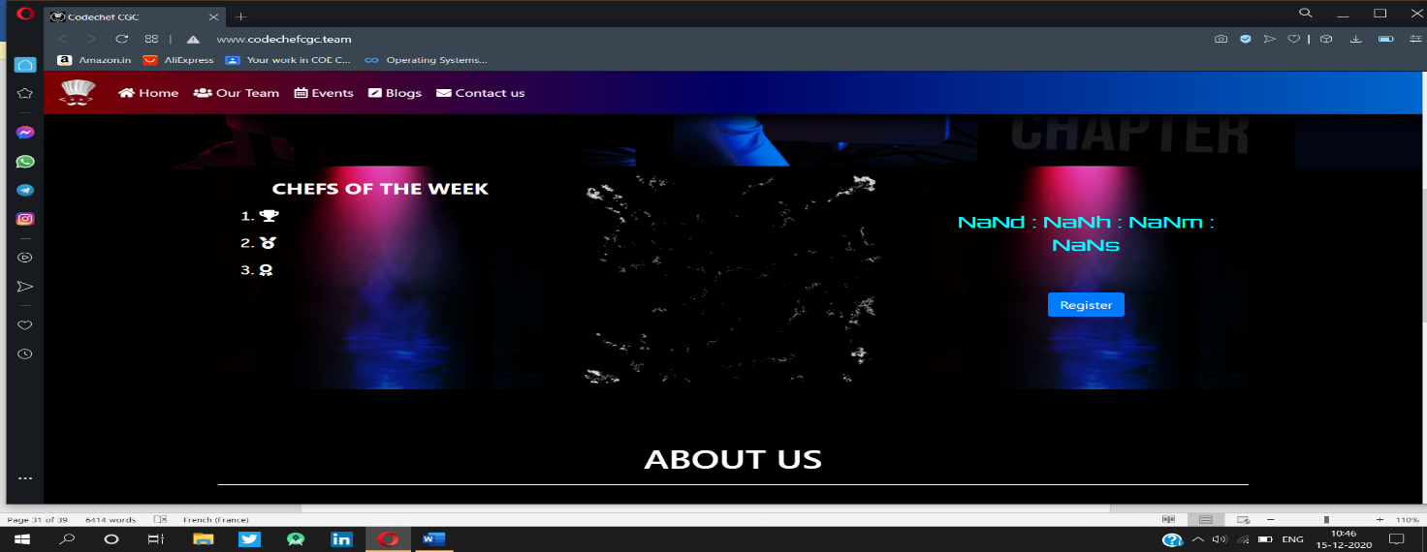

**WELCOME BANNER ON MAIN PAGE----------------------------------**

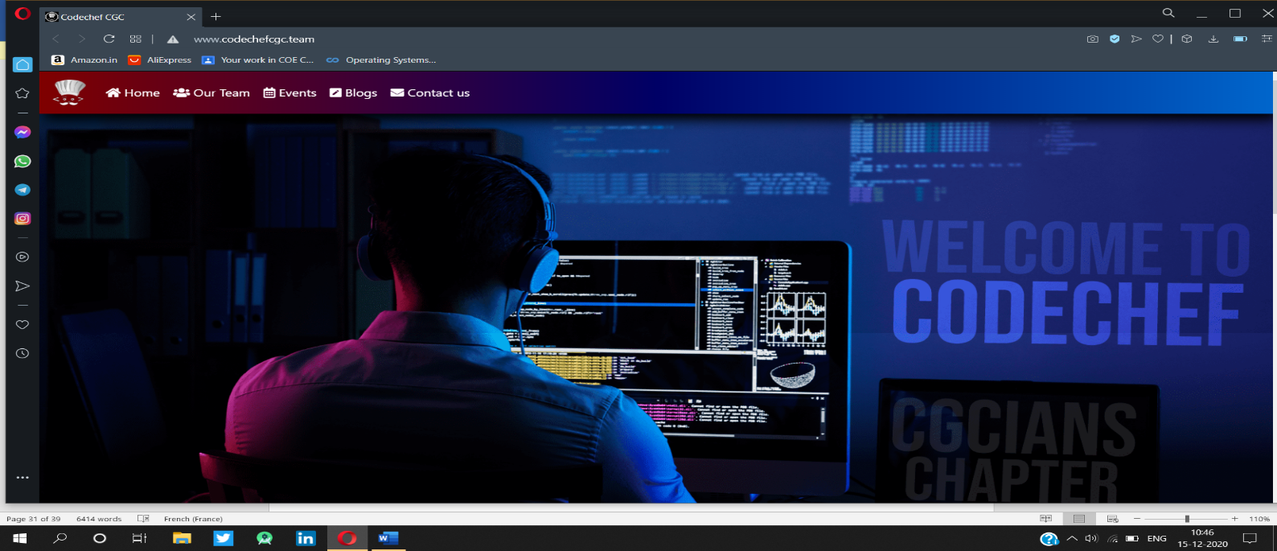

**ABOUT US PAGE------------------------------------------------------------**

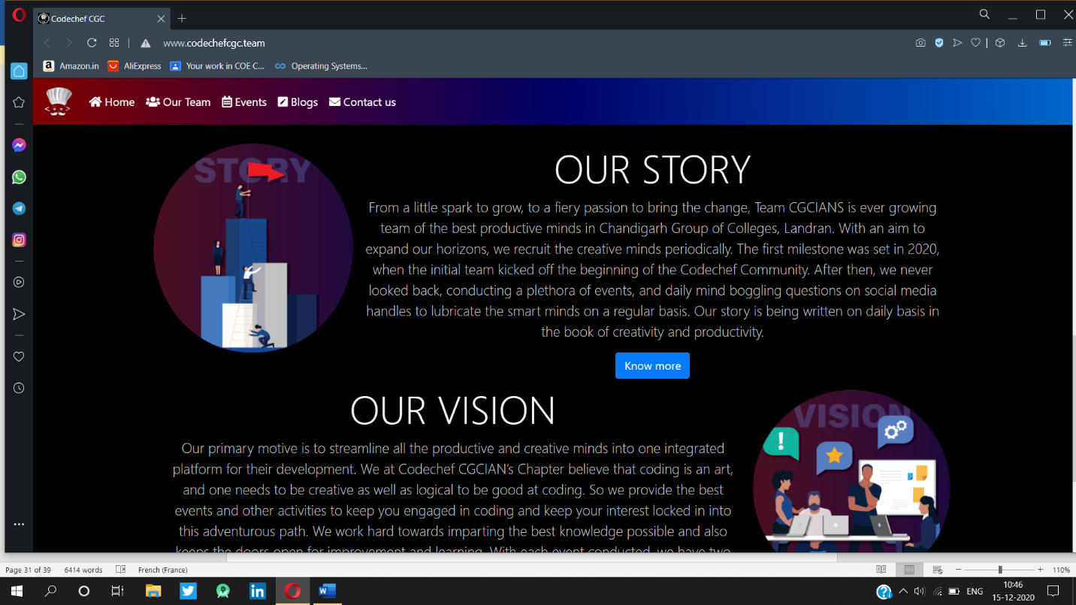

**CONTACT US PAGE/LOGIN AND REGISTER PAGE---------------------------**

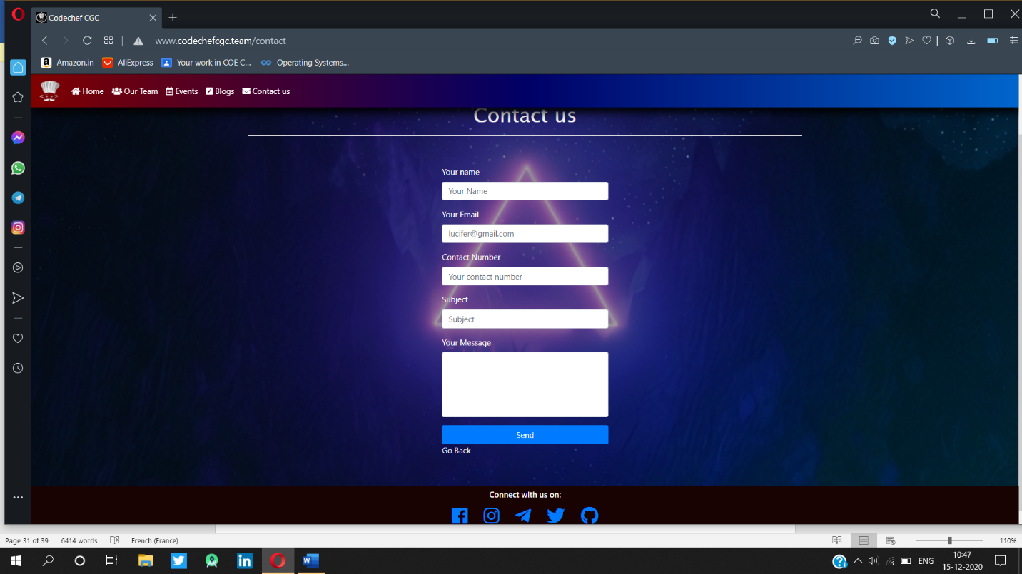

**BLOG WEBPAGE----------DISPLAYS LATEST BLOGS PUBLISHED**

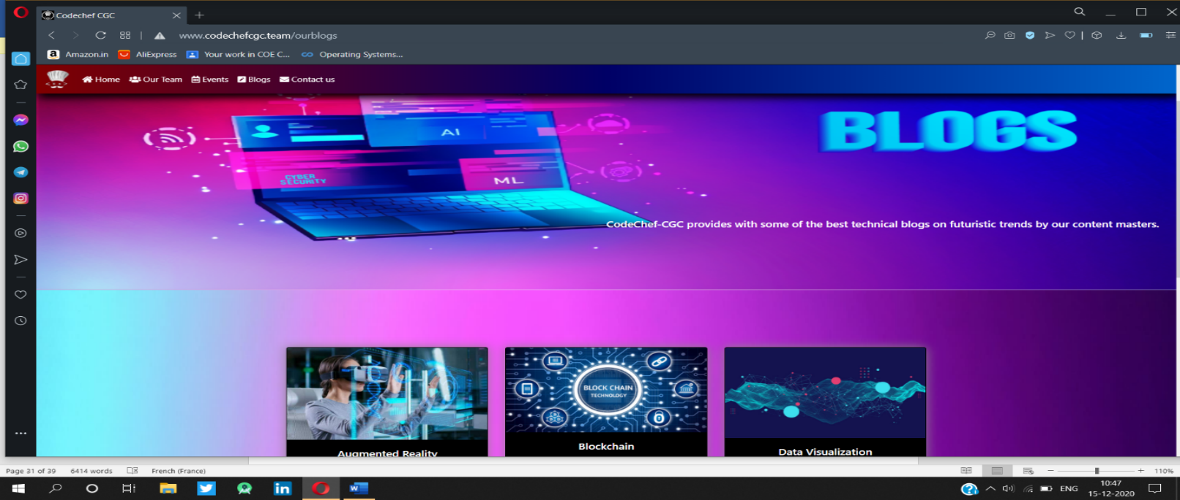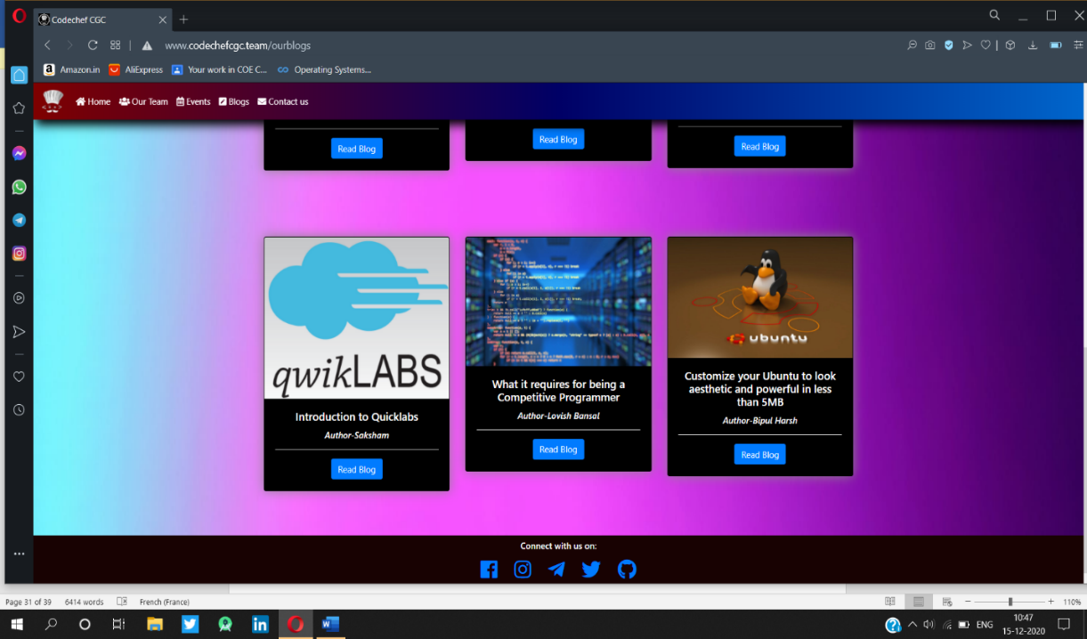

**EVENTS ORGANISED IN DIFFERENT CHAPTERS OF CODECHEF CHAPTER--------------------------------------------------**

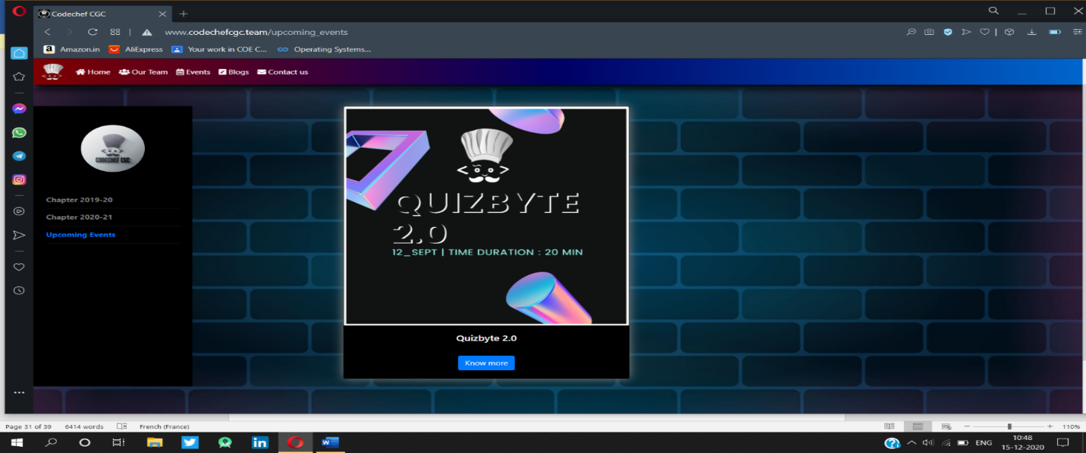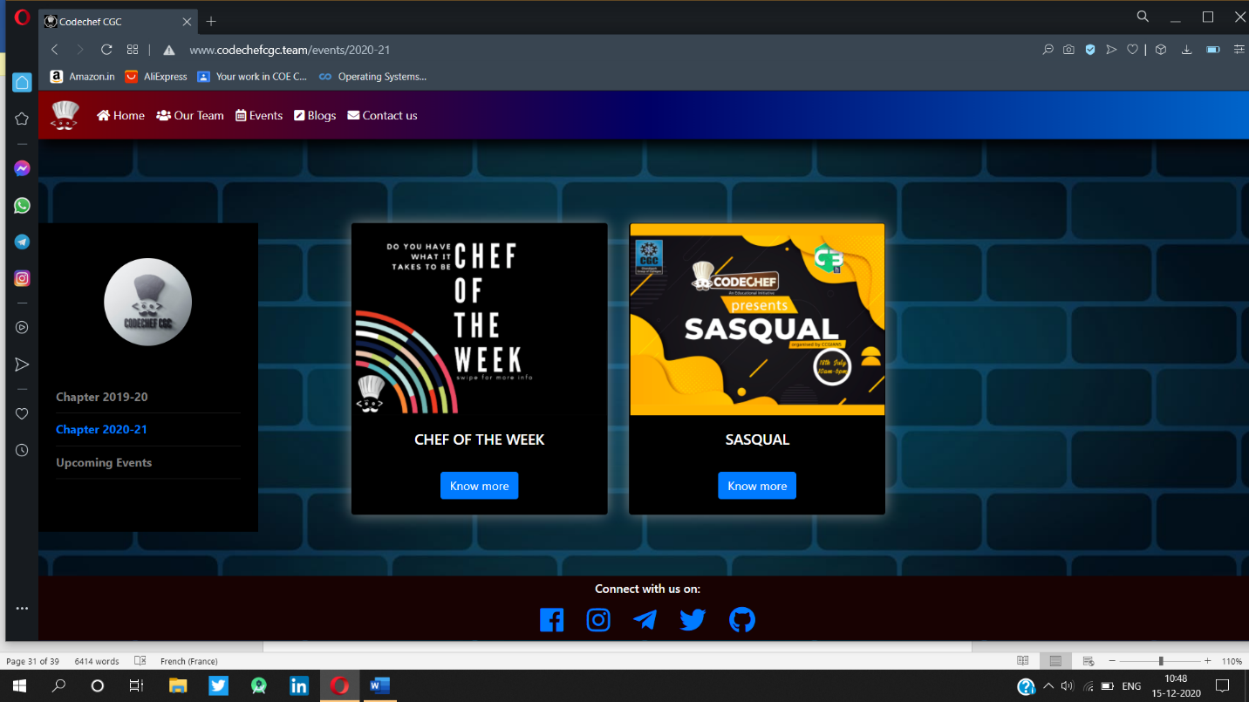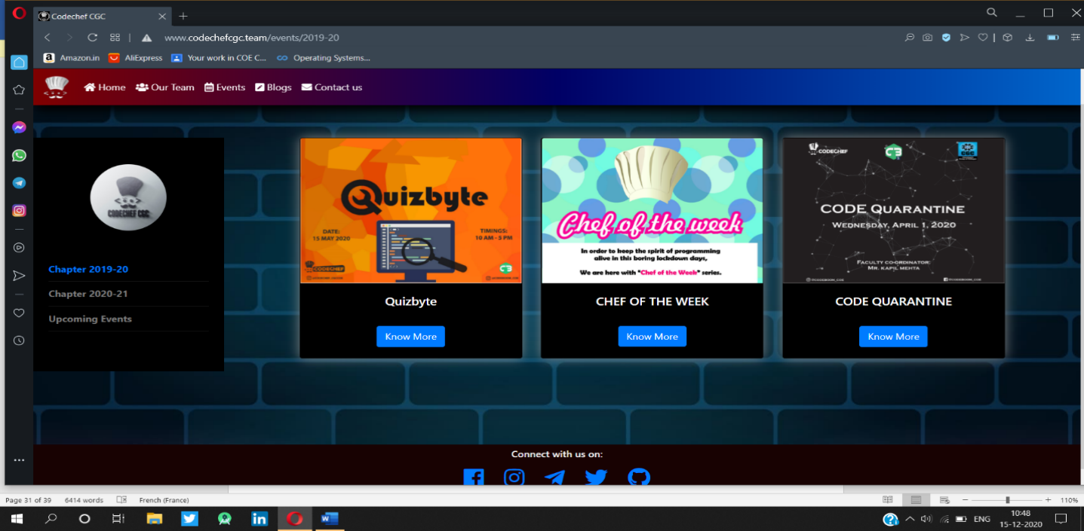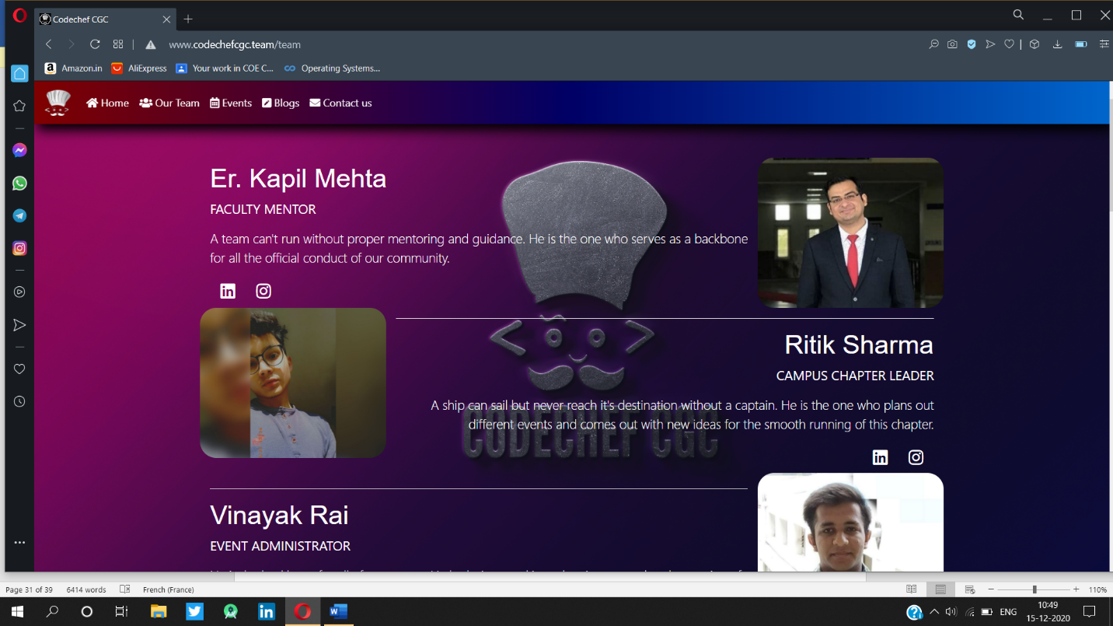

**OUR TEAM PAGE--------------------------------------------------------------**

